LECTURE NOTES

ON

STRENGTH OF MATERIALS

Course code:

Regulation: MR-19

II B. Tech

PREPARED BY

Er. B. VAMSI KRISHNA
Assistant Professor

CIVIL ENGINEERING

Malla Reddy Engineering College
(Autonomous)
Dhulapally, Kompally, Secunderabad -500100

TABLE OF CONTENTS
S.No | Name of the Unit | Page No
 | Deflection of Beams | 3
 | Deflection by Energy Methods | 19
 | Stresses in thin cylinders | 38
 | Statically Indeterminate Beams | 49
 | Three Moment Equation | 66

UNIT-I DEFLECTION OF BEAMS

Introduction:

In all practical engineering applications, when we use the different components, normally we have to operate them within the certain limits i.e. the constraints are placed on the performance and behavior of the components. For instance we say that the particular component is supposed to operate within this value of stress and the deflection of the component should not exceed beyond a particular value.

In some problems the maximum stress however, may not be a strict or severe condition but there may be the deflection which is the more rigid condition under operation. It is obvious therefore to study the methods by which we can predict the deflection of members under lateral loads or transverse loads, since it is this form of loading which will generally produce the greatest deflection of beams.

Assumption: The following assumptions are undertaken in order to derive a differential equation of elastic curve for the loaded beam

- Stress is proportional to strain i.e. hooks law applies. Thus, the equation is valid only for beams that are not stressed beyond the elastic limit.

- The curvature is always small.

- Any deflection resulting from the shear deformation of the material or shear stresses is neglected.

It can be shown that the deflections due to shear deformations are usually small and hence can be ignored.

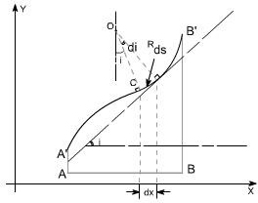

Consider a beam AB which is initially straight and horizontal when unloaded. If under the action of loads the beam deflect to a position A'B' under load or infact we say that the axis of the beam bends to a shape A'B'. It is customary to call A'B' the curved axis of the beam as the elastic line or deflection curve.

In the case of a beam bent by transverse loads acting in a plane of symmetry, the bending moment M varies along the length of the beam and we represent the variation of bending moment in B.M diagram. Futher, it is assumed that the simple bending theory equation holds good.
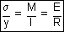

If we look at the elastic line or the deflection curve, this is obvious that the curvature at every point is different; hence the slope is different at different points.

To express the deflected shape of the beam in rectangular co-ordinates let us take two axes x and y, x-axis coincide with the original straight axis of the beam and the y – axis shows the deflection.

Futher,let us consider an element ds of the deflected beam. At the ends of this element let us construct the normal which intersect at point O denoting the angle between these two normal be di

But for the deflected shape of the beam the slope i at any point C is defined,

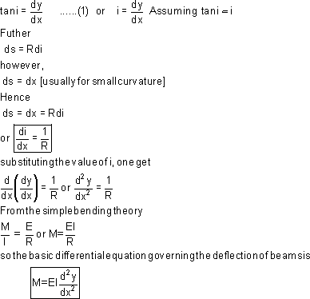

This is the differential equation of the elastic line for a beam subjected to bending in the plane of symmetry. Its solution y = f(x) defines the shape of the elastic line or the deflection curve as it is frequently called.

Relationship between shear force, bending moment and deflection: The relationship among shear force,bending moment and deflection of the beam may be obtained as

Differentiating the equation as derived

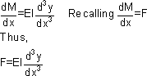

Therefore, the above expression represents the shear force whereas rate of intensity of loading can also be found out by differentiating the expression for shear force

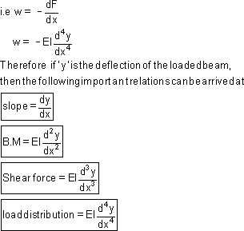

Methods for finding the deflection: The deflection of the loaded beam can be obtained various methods.The one of the method for finding the deflection of the beam is the direct integration method, i.e. the method using the differential equation which we have derived.

Direct integration method: The governing differential equation is defined as

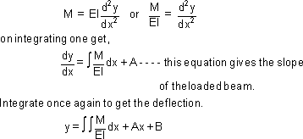

Where A and B are constants of integration to be evaluated from the known conditions of slope and deflections for the particular value of x.

Illustrative examples : let us consider few illustrative examples to have a familiarty with the direct integration method

Case 1: Cantilever Beam with Concentrated Load at the end:- A cantilever beam is subjected to a concentrated load W at the free end, it is required to determine the deflection of the beam
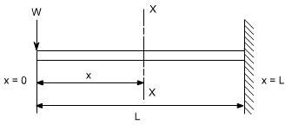

In order to solve this problem, consider any X-section X-X located at a distance x from the left end or the reference, and write down the expressions for the shear force abd the bending moment
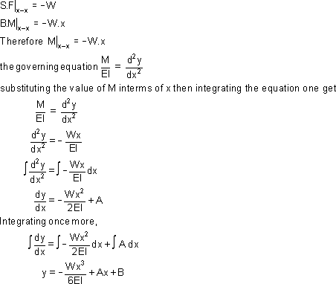

The constants A and B are required to be found out by utilizing the boundary conditions as defined below

i.e at x= L ; y= 0 (1)

at x = L ; dy/dx = 0 (2)

Utilizing the second condition, the value of constant A is obtained as

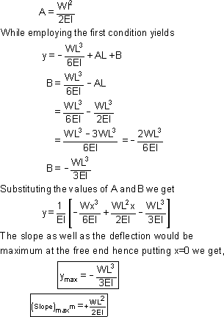

Case 2: A Cantilever with Uniformly distributed Loads:- In this case the cantilever beam is subjected to U.d.l with rate of intensity varying w / length.The same procedure can also be adopted in this case
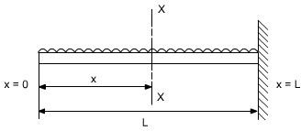

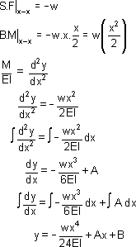

Boundary conditions relevant to the problem are as follows:

- At x = L; y = 0

- At x= L; dy/dx = 0

The second boundary conditions yields

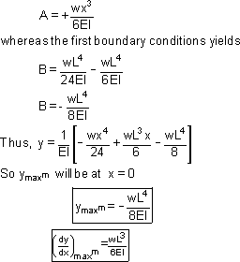

Case 3: Simply Supported beam with uniformly distributed Loads:- In this case a simply supported beam is subjected to a uniformly distributed load whose rate of intensity varies as w / length.
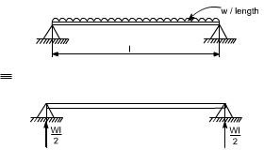

In order to write down the expression for bending moment consider any cross-section at distance of x metre from left end support.

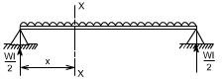
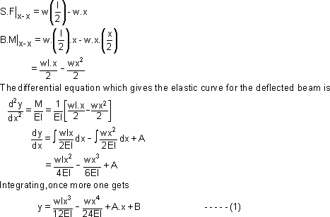

Boundary conditions which are relevant in this case are that the deflection at each support must be zero.

i.e. at x = 0; y = 0 : at x = l; y = 0

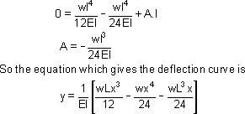
let us apply these two boundary conditions on equation (1) because the boundary conditions are on y, This yields B = 0.

Futher

In this case the maximum deflection will occur at the centre of the beam where x = L/2 [ i.e. at the position where the load is being applied ].So if we substitute the value of x = L/2
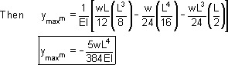

Conclusions

- The value of the slope at the position where the deflection is maximum would be zero.

- Thevalue of maximum deflection would be at the centre i.e. at x = L/2.

The final equation which is governs the deflection of the loaded beam in this case is

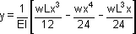

By successive differentiation one can find the relations for slope, bending moment, shear force and rate of loading.

Deflection (y)  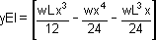 | 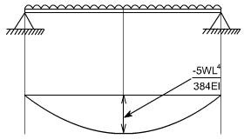
Slope (dy/dx)  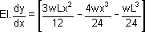 | 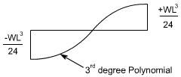
Bending Moment  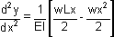 | So the bending moment diagram would be  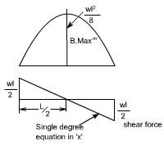
Shear Force

Shear force is obtained by taking

third derivative.

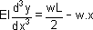
Rate of intensity of loading

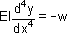

Case 4: The direct integration method may become more involved if the expression for entire beam is not valid for the entire beam. Let us consider a deflection of a simply supported beam which is subjected to a concentrated load W acting at a distance 'a' from the left end.
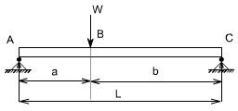

Let R₁ & R₂ be the reactions then,

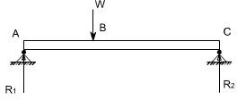
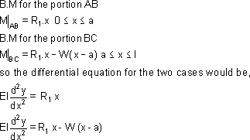

These two equations can be integrated in the usual way to find ‘y' but this will result in four constants of integration two for each equation. To evaluate the four constants of integration, four independent boundary conditions will be needed since the deflection of each support must be zero, hence the boundary conditions (a) and (b) can be realized.

Further, since the deflection curve is smooth, the deflection equations for the same slope and deflection at the point of application of load i.e. at x = a. Therefore four conditions required to evaluate these constants may be defined as follows:

- at x = 0; y = 0 in the portion AB i.e. 0 ≤ x ≤ a

- at x = l; y = 0 in the portion BC i.e. a ≤ x ≤ l

- at x = a; dy/dx, the slope is same for both portion

- at x = a; y, the deflection is same for both portion By symmetry, the reaction R₁ is obtained as

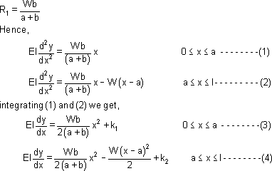

Using condition (c) in equation (3) and (4) shows that these constants should be equal, hence letting

K₁ = K₂ = K

Hence

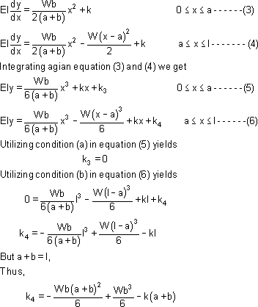

Now lastly k₃ is found out using condition (d) in equation (5) and equation (6), the condition
(d) is that,

At x = a; y; the deflection is the same for both portion

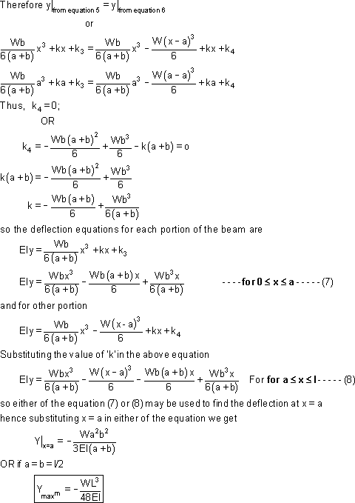

ALTERNATE METHOD: There is also an alternative way to attempt this problem in a more simpler way. Let us considering the origin at the point of application of the load,
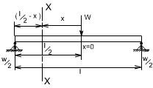
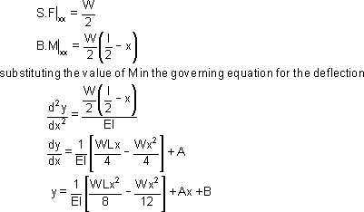

Boundary conditions relevant for this case are as follows

- at x = 0; dy/dx= 0 hence, A = 0
- at x = l/2; y = 0 (because now l / 2 is on the left end or right end support since we have taken the origin at the centre)

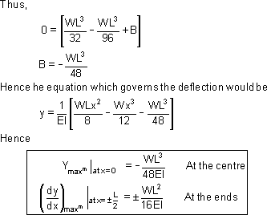

Hence the integration method may be bit cumbersome in some of the case. Another limitation of the method would be that if the beam is of non uniform cross section,

i.e. it is having different cross-section then this method also fails.

So there are other methods by which we find the deflection like

- Macaulay's method in which we can write the different equation for bending moment for different sections.

- Area moment methods

- Energy principle methods

UNIT -II
DEFLECTION BY ENERGY METHODS

Principle of Virtual Work

Many problems in structural analysis can be solved by the principle of virtual work. Consider a simply supported beam as shown in Fig.5.1a, which is in equilibrium

under the action of real forces F1 , F2 , ,
Fn
at co-ordinates 1,2,....., n respectively.

Let u1, u₂ , ,
u_{n}
be the corresponding displacements due to the action of

forces F₁, F₂ ,......., F_{n} . Also, it produces real internal stresses σij and real internal strains εij inside the beam. Now, let the beam be subjected to second system of
forces (which are virtual not real) δF1,δF2 ,......,δFn in equilibrium as shown in

Fig.5.1b. The second system of forces is called virtual as they are imaginary and they are not part of the real loading. This produces a displacement configuration δu₁,δu₂ , ,δu_{n} . The virtual loading system produces virtual internal
stresses δσ ij and virtual internal strains δεij inside the beam. Now, apply the
second system of forces on the beam which has been deformed by first system of forces. Then, the external loads F_{i} and internal stresses σij do virtual work by
moving along δui and δεij . The product ∑ Fiδui is known as the external virtual work. It may be noted that the above product does not represent the conventional
work since each component is caused due to different source i.e. δui is not due

to F . Similarly the product∑σijδεij is the internal virtual work. In the case of is the internal virtual work. In the case of is the internal virtual work. In the case configuration δu₁ ,δu₂
i
, ,δu_{n} . The virtual loading system produces virtual internal
stresses δσ ij and virtual internal strains δεij inside the beam. Now, apply the second system of forces on the beam which has been deformed by first system of

forces. Then, the external loads F_{i}
and internal stresses σij do virtual work by

moving along δui and δεij . The product ∑ Fiδui is known as the external virtual work. It may be noted that the above product does not represent the conventional
work since each component is caused due to different source i.e. δui is not due
to F_{i} . Similarly the product ∑σijδεij is the internal virtual work. In the case of

deformable body, both external and internal forces do work. Since, the beam is in equilibrium, the external virtual work must be equal to the internal virtual work. Hence, one needs to consider both internal and external virtual work to establish equations of equilibrium.

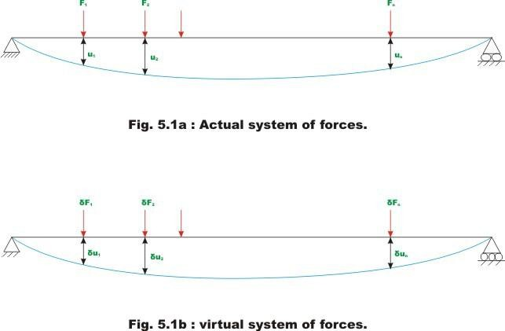

Principle of Virtual Displacement
A of true forces moving through the corresponding virtual displacements of the system
i.e. Fiui is equal to the total internal virtual work for every kinematically admissible (consistent with the constraints) virtual displacements That is virtual displacements should be continuous within the structure and also it must satisfy boundary conditions. deformable body is in equilibrium if the total external virtual work done by the system

where σ ij
∑ F_{i} δu_{i}
= ∫σ ij δεij
dv

Fi and δεi are the virtual strains due to virtual displacementsδu_{i} .

Principle of Virtual Forces
For a deformable body, the total external complementary work is equal to the total internal complementary work for every system of virtual forces and stresses that satisfy the equations of equilibrium.

∑δFi ui = ∫δσ ij ε ij dv (5.2)

where δσij are the virtual stresses due to virtual forces δFi and εij are the true strains due to the true displacements u_{i} .
As stated earlier, the principle of virtual work may be advantageously used to
calculate displacements of structures. In the next section let us see how this can be used to calculate displacements in a beams and frames. In the next lesson, the truss deflections are calculated by the method of virtual work.

Unit Load Method
The principle of virtual force leads to unit load method. It is assumed throughout our discussion that the method of superposition holds good. For the derivation of unit load method, we consider two systems of loads. In this section, the principle of virtual forces and unit load method are discussed in the context of framed structures. Consider a cantilever beam, which is in equilibrium under the action of
a first system of forces F1, F2 ,....., Fn causing displacements u1, u2 , , un as shown in

Fig. 5.2a. The first system of forces refers to the actual forces acting on the

structure. Let the stress resultants at any section of the beam due to first system of forces be axial force ( P ), bending moment ( M ) and shearing force (V ). Also the corresponding incremental deformations are axial deformation ( d⊗ ), flexural deformation ( dθ ) and shearing deformation ( dλ ) respectively.
For a conservative system the external work done by the applied forces is equal to the internal strain energy stored. Hence,

Now, consider a second system of forces δF1,δF2 ,.....,δFn , which are virtual and causing virtual displacements δu₁,δu₂,.....,δun respectively (see Fig. 5.2b). Let the virtual stress resultants caused by virtual forces be δPv , δMv and δVv at any cross section of the beam. For this system of forces, we could write

n L 2 L 2 L 2
  - ∑δFδu δP ds δM ds δV ds
= ∫ v + ∫ v + ∫ v
0
(5.4)

  - _{i=1} ^{i} ^{i} 2EA 2EI 2AG
0 0

where δP_{v}, δM_{v} and δV_{v} are the virtual axial force, bending moment and shear force respectively. In the third case, apply the first system of forces on the beam, which
has been deformed, by second system of forces δF1,δF2 ,.....,δFn as shown in Fig

5.2c. From the principle of superposition, now the deflections will be
(u₁ + δu₁),(u₂ + δu₂),. ,(u_{n} + δu_{n} ) respectively

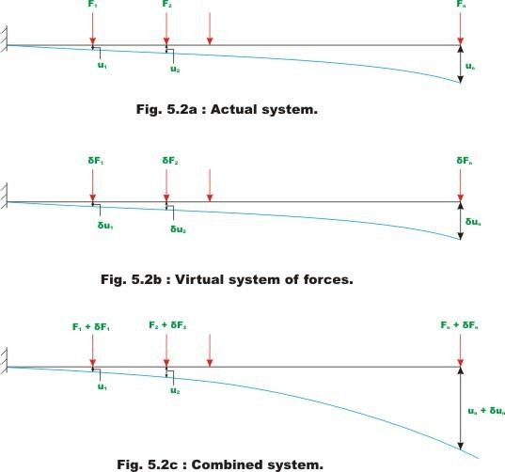

In equation (5.5), the term on the left hand side (∑δF_{j}u _{j} ), represents the work done by virtual forces moving through real displacements. Since virtual forces act

at its full value, does not appear in the equation. Subtracting equation (5.3) and (5.4) from equation (5.5) we get,

n L L L
∑δF_{j}u _{j} = ∫δP_{v}d⊗ + ∫δM_{v}dθ +
∫δV_{v}dλ
j =1 0 0 0

From Module 1, lesson 3, we know that

(5.6)

d⊗ = Pds , dθ =
Mds and
dλ = Vds . Hence,

EA EI AG

n L L L
∑δF u δP Pds δM Mds δV Vds
= ∫ v + ∫ v + ∫ v

(5.7)

j =1
j j EA 0 EI
0

0 AG

Notethat does not appear on right side of equation (5.7) as the virtual system resultants act at constant values during the real displacements. In the present case δPv = 0 and if we neglect shear forces then we could write equation (5.7) as

n L δM Mds

∑δFjuj = ∫ v
EI
(5.8)

j =1 0

24

If the value of a particular displacement is required, then choose the

corresponding force δFi =
1
and all other forces δF_{j} = 0 ( j = 1,2,....,i −1,i +1, , n) .

Then the above expression may be written as,

L δM Mds
(1)u = ∫ v (5.9)
^{i} EI
0

where δMv are the internal virtual moment resultants corresponding to virtual force at i-th co-ordinate, δF_{i} = 1 . The above equation may be stated as,

(unit virtual load ) unknown true displacement

= ∫(virtual stress resultants )(real deformations) ds.

(5.10)

The equation (5.9) is known as the unit load method. Here the unit virtual load is applied at a point where the displacement is required to be evaluated. The unit load method is extensively used in the calculation of deflection of beams, frames and trusses. Theoretically this method can be used to calculate deflections in statically determinate and indeterminate structures. However it is extensively used in evaluation of deflections of statically determinate structures only as the method requires a priori knowledge of internal stress resultants.

Example
A cantilever beam of span L is subjected to a tip moment
⎛ 3L ⎞
M₀ as shown in Fig 5.3a.

Evaluate slope and deflection at a point ⎜
given beam to be constant.
□ from left support. Assume EI of
□ the
4

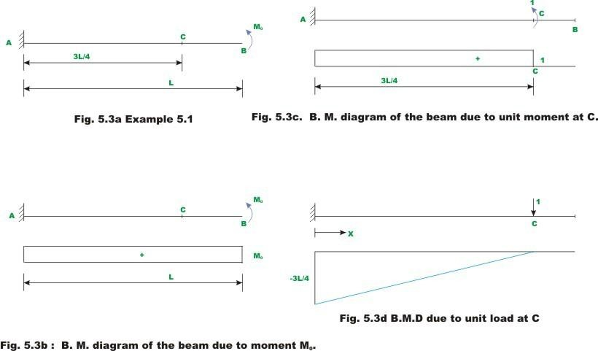

Slope at C

To evaluate slope at C , a virtual unit moment is applied at C as shown in Fig 5.3c. The bending moment diagrams are drawn for tip moment M0 and unit moment applied at C and is shown in fig 5.3b and 5.3c respectively. Let c be the rotation at C due to moment M0 applied at tip. According to unit load method, the rotation

at C , c is calculated as,

L δM
(x)M
(x)dx

(1)θ
0
₌ ∫ v
(1)

^{c} EI

M (x)
where δM _{v} (x) and

are the virtual moment resultant and real moment

resultant at any section x . Substituting the value of δM_{v} (x)
expression, we get
and M (x) in the above

3L / 4 (1)Mdx ^{L} (0)Mdx

(1)θc = ∫
0

θ
EI

= 3ML
+ ∫
3L / 4 EI

(2)

^{c} 4EI

Vertical deflection at C

To evaluate vertical deflection at C , a unit virtual vertical force is applied ac C as shown in Fig 5.3d and the bending moment is also shown in the diagram. According to unit load method,

L δM
(x)M
(x)dx

- u
₌ ∫ v
(3)

^{A} EI
0
3L

In the present case,
δM_{v} (x)=
−
□ 4
− x

and
M (x)= +M ₀

28

3L
3L
₄ − − x M
u_{A} = ∫ 4 dx
0 EI
^{3L} 3
= − M L − x dx

∫4
□
EI ⁰ 4
3L

= − M ϒ3L

′ x−
x2 ⁄ 4
∞

EI ≤ 4 2 ƒ0 9ML²
= − ( ↑ ) (4)
32EI

29

Example 5.2
Find the horizontal displacement at joint B of the frame ABCD as shown in Fig. 5.4a by unit load method. Assume EI to be constant for all members.

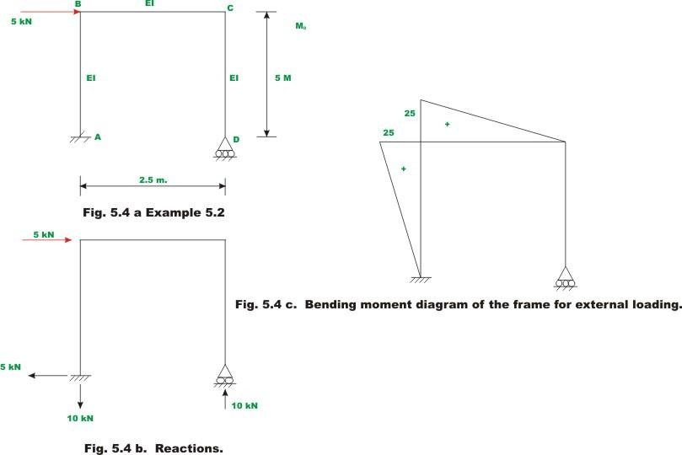

The reactions and bending moment diagram of the frame due to applied external loading are shown in Fig 5.4b and Fig 5.4c respectively. Since, it is required to calculate horizontal deflection at B, apply a unit virtual load at B as shown in Fig. 5.4d. The resulting reactions and bending moment diagrams of the frame are shown in Fig 5.4d.

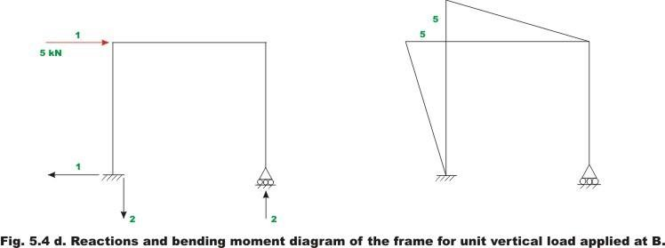

Now horizontal deflection at B, u_{B} may be calculated as

D δM
  - × u ^{B} = ∫ v
(x)M
(x)dx
(1)

^{H} EI
A

B δM (x)M (x)dx C δM (x)M (x)dx D δM (x)M (x)dx
= ∫ v + ∫ v + ∫ v A EI B EI C EI

5 (x)(5x)dx ^{2.5}2(2.5− x)10(2.5− x)dx
= ∫ + ∫ + 0
0 EI 0 EI

5 (5x2 )dx 2.520(2.5− x)2 dx
= ∫ + ∫
0 EI 0 EI

= 625 + 312.5 = 937.5 3EI 3EI 3EI

Hence,
u = 937.5 ( →) (2)
^{A} 3EI

Example
Find the rotations of joint B and C of the frame shown in Fig. 5.4a. Assume EI to be constant for all members.
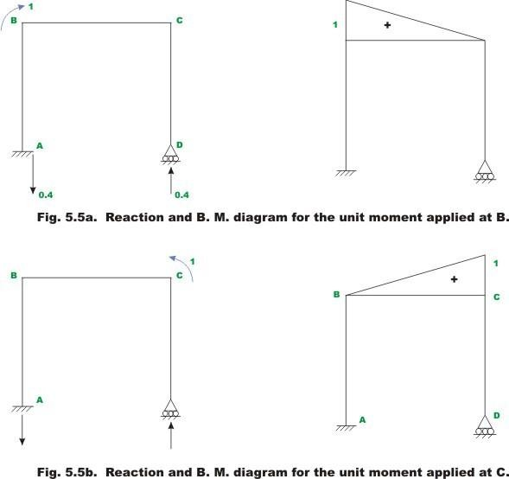

32

Rotation at B

Apply unit virtual moment at B as shown in Fig 5.5a. The resulting bending moment diagram is also shown in the same diagram. For the unit load method, the relevant equation is,

(1)×θ
D δM (x)M (x)dx
₌ ∫ v
^{B} EI
A

(1)

wherein, θB is the actual rotation at B, δ M_{v} (x) is the virtual stress resultant in the frame due to the virtual load and D M (x)dx is the actual deformation of the frame
∫A EI
due to real forces.

Now
,
M (x)=10(2.5− x) and δM (x)= 0.4(2.5− x)
v

Substituting the values of M (x) and δMv (x) in the equation (1),

2.5
θB = 4 ∫ (2.5− x)2dx
EI 0

4 ϒ 5x²
= ′6.25x −

x3 ⁄
2.5
= 62.5 (2)

+ ∞
EI ≤ 2 3
ƒ₀
3EI

Rotation at C

For evaluating rotation at C by unit load method, apply unit virtual moment at C as shown in Fig 5.5b. Hence,

(1)×θ
D δM (x)M (x)dx
₌ ∫ v
^{C} EI
A

(3)

^{2.5}10(2.5 − x)(0.4x)

θC = ∫0 EI dx

4 ϒ2.5x²
x
= ′

3 ⁄ 2.5
= 31.25

EI ≤ 2
−
∞3 3EI
0
(4)

Unit Displacement Method

Consider a cantilever beam, which is in equilibrium under the action of a system of forces F₁, F₂,....., F_{n} . Let u₁, u₂,....., u_{n} be the corresponding displacements and
P, M and V be the stress resultants at section of the beam. Consider a second

system of forces (virtual) F1, F2
,. ,F_{n}
causing virtual

displacementsu₁,u₂,.....,u_{n} . Let P_{v} ,M_{v}
and
V_{v} be the virtual axial force,

bending moment and shear force respectively at any section of the beam.
Apply the first system of forces F1, F2,....., Fn on the beam, which has been

previously bent by virtual forces displacements we have,
F₁,F₂,....., F_{n} . From the principle of virtual

n


j=1
F_{j}δu_{j}
M(x)δM (x)ds
₌ ∫ v
EI

= ∫σ Tδε δv
V

(5.11)

35

The left hand side of equation (5.11) refers to the external virtual work done by the system of true/real forces moving through the corresponding virtual displacements of the system. The right hand side of equation (5.8) refers to internal virtual work done. The principle of virtual displacement states that the external virtual work of the real forces multiplied by virtual displacement is equal to the real stresses multiplied by virtual strains integrated over volume. If the value of a particular force element is required then choose corresponding virtual displacement as unity. Let

us say, it is required to evaluate F₁ , then choose u₁ 1 and u_{i} 0 From equation (5.11), one could write,
i = 2,3,....., n .

(1) F1 = ∫ M (δM_{v} )₁ds

EI (5.12)

where, M _{v}
1
is the internal virtual stress resultant for u 1. Transposing the
1

above equation, we get

F₁ = ∫
(δM_{v})₁Mds
EI (5.13)

The above equation is the statement of unit displacement method. The above equation is more commonly used in the evaluation of stiffness co-efficient kij .

Apply real displacements u1, ,
un
in the structure. In that set u2 1 and the other

all displacements ui
0
(i 1,3,......, n) . For such a case the quantity Fj in

36

displacement u1 1. Now according to unit displacement method,

(1)k12 = ∫ (δM_{v})₁M ₂ds
EI (5.14)

37

UNIT - III

Stresses in thin cylinders

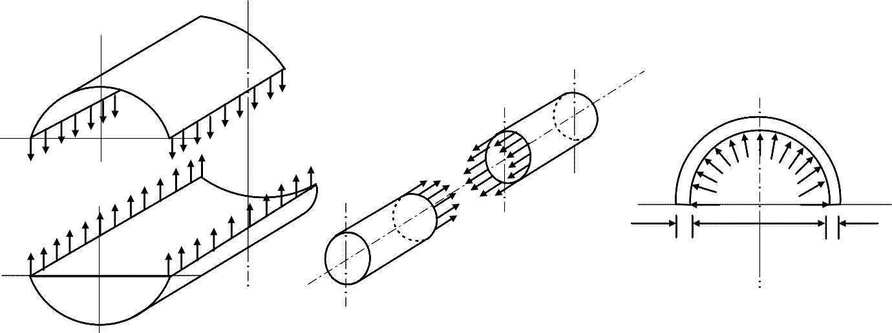If the wall thickness is less than about 7% of the inner diameter then the cylinder may be treated as a thin one. Thin walled cylinders are used as boiler shells, pressure tanks, pipes and in other low pressure processing equipments. In general three types of stresses are developed in pressure cylinders viz. circumferential or hoop stress, longitudinal stress in closed end cylinders and radial stresses. These stresses are demonstrated in figure-9.1.1.1.
p
t
2r
t
C

- (b) (c)
F- (a) Circumferential stress (b) Longitudinal stress and (c) Radial stress developed in thin cylinders.

In a thin walled cylinder the circumferential stresses may be assumed to be constant over the wall thickness and stress in the radial direction may be neglected for the analysis. Considering the equilibrium of a cut out section the circumferential stress  and longitudinal stress z can be found. Consider a section of thin cylinder of radius r, wall thickness t and length L and subjected to an internal pressure p as shown in figure-9.1.1.2(a). Consider now an element of included angle d at an angle of  from vertical. For equilibrium we may write
π

2

2∫ prdθLcos θ = 2σ_{θ}tL
0

pr
This gives σθ =

t
Considering a section along the longitudinal axis as shown in figure-9.1.1.2 (b)

we may write pr² = z (r ²-r ²)
o
i

where ri and ro are internal and external radii of the vessel and since ri ro = r (say) and ro – ri = t we have z =

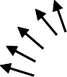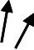σθ σθ
σ_{z}
P
t
θ
p
r
dθ

(b)
F- (a) Circumferential stress in a thin cylinder (b) Longitudinal stress in a thin cylinder

Thin walled spheres are also sometimes used. Consider a sphere of internal radius r subjected to an internal pressure p as shown in figure-9.1.1.3. The circumferential and longitudinal stresses developed on an element of the surface of the sphere are equal in magnitude and in the absence of any shear stress due to symmetry both the stresses are principal stresses. From the equilibrium condition in a cut section we have
σ1 = σ2=

σ₂
σ₁
σ
P
F- Stresses in a spherical shell

Design Principles

Pressure vessels are generally manufactured from curved sheets joined by welding. Mostly V– butt welded joints are used. The riveted joints may also be used but since the plates are weakened at the joint due to the rivet holes the plate thickness should be enhanced by taking into account the joint efficiency. It is probably more instructive to follow the design procedure of a pressure vessel. We consider a mild steel vessel of 1m diameter comprising a 2.5 m long

cylindrical section with hemispherical ends to sustain an internal pressure of ( say) 2MPa.
The plate thickness is given by ≥ prσyt t where σyt is the tensile yield stress. The minimum plate thickness should conform to the “Boiler code” as given in table-

Minimum plate thickness

Boiler diameter(m) | ≤ 0.90 | 0.94 to  1.37 | 1.4 to 1.80 | - 1.80
Plate thickness  (mm) | 6.35 | 8.00 | 9.525 | 12.70

The factor of safety should be at least 5 and the minimum ultimate stresses of the plates should be 385 MPa in the tension, 665 MPa in compression and 308 MPa in shear.

This gives tc
≥ 2x10⁶ x0.5
, i.e., 13 mm. Since this value is more than the value
(385x10⁶ / 5)

prescribed in the code the plate thickness is acceptable. However for better safety we take tc =15mm. Thickness ts of the hemispherical end is usually taken as half of this value and we take ts≈ 8mm.

Welded Joint

The circumferential stress developed in the cylinder σθ =

pr t_{c}
. With p=2MPa ,

r=0.5m and tc = 15 mm, σθ =67 MPa and since this is well below the allowable stress of 100 MPa ( assumed) the butt welded joint without cover plate would be adequate.
Consider now a butt joint with 10mm cover plates on both sides, as shown in

figure-

15 mm thick plate

Fillet weld

F- Longitudinal welded joint with cover plates.

The stress induced in the weld σw is given by Fc = 2σwLtcsin45⁰
where L is the weld length. We may now write Fc = σθ t.L and therefore σw is

given by σ_{w} = σ_{θ}
t
0 = 67x

15
o which gives σw = 71 MPa which

t_{c} 2 sin 45 10x2x sin 45
again is adequate. For increased safety we may choose the butt joint with 10mm thick cover plates. The welding arrangement of the vessel is shown in figure-

Full penetration butt weld 8 mm thick plate

Fillet weld Longitudinal joint
1 m

15 mm thick plate

F- The welding arrangement of the joint.

Riveted Joint

The joints may also be riveted in some situations but the design must be checked for safety. The required plate thickness must take account the joint efficiency η.

This gives tc = pr
ησ_{ty}
Substituting p = 2MPa, r = 0.5 m, η = 70 % and σty = (385/5)

MPa we have tc = 18.5 mm. Let us use mild steel plate of 20 mm thickness for the cylinder body and 10mm thick plate for the hemispherical end cover. The cover plate thickness may be taken as 0.625tc i.e. 12.5 mm. The hoop stress is

now given by σθ =

MN per meter.
pr = 50MPa t_{c}
and therefore the rivets must withstand σθtc i.e. 1

We may begin with 20mm diameter rivets with the allowable shear and bearing stresses of 100 MPa and 300 MPa respectively. This gives bearing load on a
single rivet Fb = 300x10⁶x0.02x0.02 = 120 kN. Assuming double shear
π
the shearing load on a single rivet FS = 100x10⁶x2x (0.02)2 = 62.8kN.

4

The rivet pitch based on bearing load is therefore (120 kN/ 1MN per meter)
i.e. 0.12m and based on shearing load is (62.8 kN/ 1MN per meter) i.e. 0.063m. We may therefore consider a minimum allowable pitch of 60mm. This gives approximately 17 rivets of 20 mm diameter per meter. If two rows are used the pitch is doubled to 120mm. For the hemispherical shaped end cover the bearing load is 60 kN and therefore the rivet pitch is again approximately 60 mm.
The maximum tensile stress developed in the plate section is
σt = 1x10⁶/[(1-17x0.02)x0.02] = 75.76 MPa which is a safe value considering the allowable tensile stress of 385 MPa with a factor of safety of 5. A longitudinal riveted joint with cover plates is shown in figure–9.1.2.3 and the whole riveting arrangement is shown in figure-9.1.2.4.

20 mm thick plate

12.5 mm thick plates

20 mm diameter rivets at 120 mm pitch

F- A longitudinal joint with two cover plates

20 mm thick plate
20 mm φ rivets @

12.5 mm thick cover plates
+ +
+ +
+ + + + + + + +

+ + + + +
+ + +

+ +
+ +

60 mm pitch length

10 mm thick plate

10 mm thick cover plates 20 mm φ rivets @ 120mm pitch length

9.1.2.4F- General riveting arrangement of the pressure vessel.

Summary of this Lesson

Stresses developed in thin cylinders are first discussed in general and then the circumferential ( σ_{θ} ) and longitudinal stresses ( σ_{z} ) are expressed in terms of internal pressure, radius and the shell thickness. Stresses in a spherical shell are also discussed. Basic design principle of thin cylinders are considered. Design of both welded and riveted joints for the shells are discussed.

UNIT-IV

Introduction

A strucure in which the laws of statics are not sufficient to determine all the unknown forces or moments is said to be statically indeterminate. Such structures are analyzed by writing the appropriate equations of static equilibrium and additional equations pertaining to the deformation and constraints known as compatibility condition.

The statically indeterminate structures are frequently used for several advantages. They are relatively more economical in the requirement of material as the maximum bending moments in the structure are reduced. The statically indeterminate are more rigid leading to smaller deflections. The disadvantage of the indeterminate structure is that they are subjected to stresses when subjected to temperature changes and settlements of the support. The construction of indeterminate structure is more difficult if there are dimensional errors in the length of members or location of the supports.

This chapter deals with analysis of statically indeterminate structures using various force methods.

Analysis of Statically Indeterminate Beams

The moment area method and the conjugate beam method can be easily applied for the analysis of statically indeterminate beams using the principle of superposition. Depending upon the degree of indeterminacy of the beam, designate the excessive reactions as redundant and modify the support. The redundant reactions are then treated as unknown forces. The redundant reactions should be such that they produce the compatible deformation at the original support along with the applied loads. For example consider a propped cantilever beam as shown in Figure 5.1(a). Let the reaction at B be R as shown in Figure 5.1(b) which can be obtained with the compability condition that the downward vertical deflection of B due to applied loading (i.e. shown in Figure

5.1(c)) should be equal to the upward vertical deflection of B due to R (i.e. shown in Figure 5.1(d)).
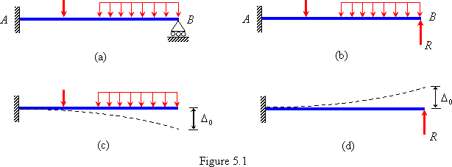

Example Determine the support reactions of the propped cantilever beam as shown in Figure 5.2(a).
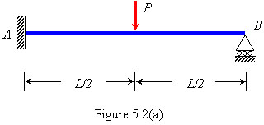

Solution: The static indeterminacy of the beam is = 3 – 2 = 1. Let reaction at B is R acting in the upward direction as shown in Figure 5.2(b). The condition available is that the .

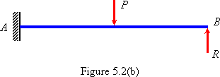

(a) Moment area method

The bending moment diagrams divided by EI of the beam are shown due to P and R in Figures 5.2(c) and (d), respectively.

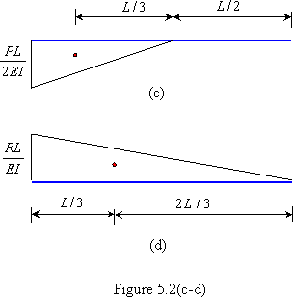

Since in the actual beam the deflection of the point B is zero which implies that the deviation of point B from the tangent at A is zero. Thus,

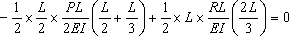
or

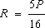
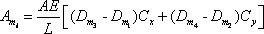

Taking moment about A , the moment at A is given by

The vertical rection at A is

The bending moment diagram of the beam is shown in Figure 5.2(e).

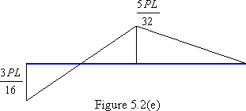

(b) Conjugate beam method

The corresponding conjugate beam of the propped cantilever beam and loading acting on it are shown in Figure 5.2(f).

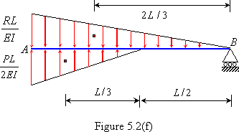

The unknown R can be obtained by taking moment about B i.e.

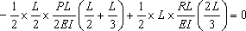

Example 5.2 Determine the support reactions of the fixed beam with internal hinge as shown in Figure 5.3(a).

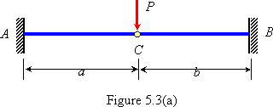

Solution: The static indeterminacy of the beam is = 4-2-1 =1 Let the shear in the internal hinge be R . The free body diagrams of the two separated portions of the beam are shown in Figure 5.3(b) along with their M/EI diagrams. The unknown R can be obtained with the condition that the vertical deflection of the free ends of the two separated cantilever beams is identical.

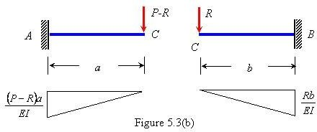

Consider AC : The vertical displacement of C is given by

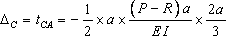

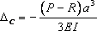
or

Consider CB : The vertical displacement of C is given by

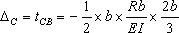
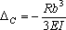

Equating the from Eqs. (i) and (ii)

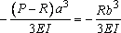

Solving for R will give

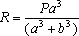

The reactions at the supports are given by

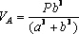
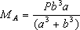
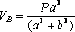
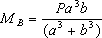

Example 5.3 Determine the support reactions of the fixed beam with one end fixed and other supported on spring as shown in Figure 5.4(a). The stiffness of spring is .
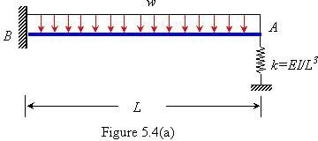

Solution: The static indeterminacy of the beam is = 3–2 =1. Let the force in the spring be R . The free body diagram of the beam along with the M/EI diagram and spring are shown in Figure 5.4(b) and (c), respectively. The unknown R can be obtained with the condition that the vertical deflection of the free end of the beam and spring is identical.

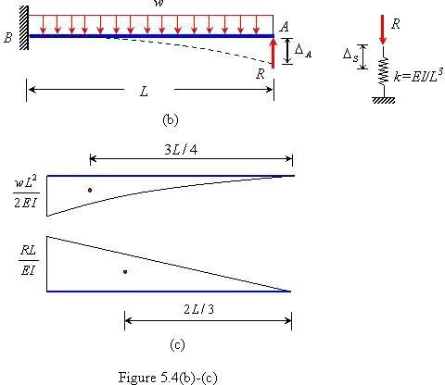

Using moment area theorem, the deflection of free end A of the beam is

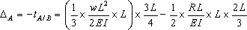

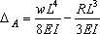

The downward deflection of spring is

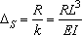

Equating and
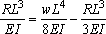

The bending moment at B

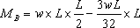
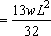

The vertical reaction at B

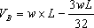

The force in the spring 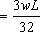 (compressive)

The bending moment diagram of the beam is shown in Figure 5.4(d).

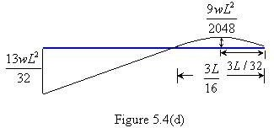

Example 5.4 Determine the support reactions of the fixed beam as shown in Figure 5.5(a). The beam carries a uniformly distributed load, w over the left half span.

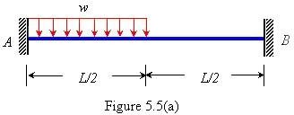

Solution: The static indeterminacy of the beam is = 4-2 =2. Let the reactions at B be the unknown as shown in Figure 5.5(b).

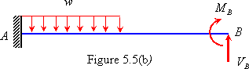

(a) Moment Area Method
The free body diagram of the beam is shown below along with their M/EI diagrams. The unknowns and can be obtained with the condition that the vertical deflection and slope at B are zero.

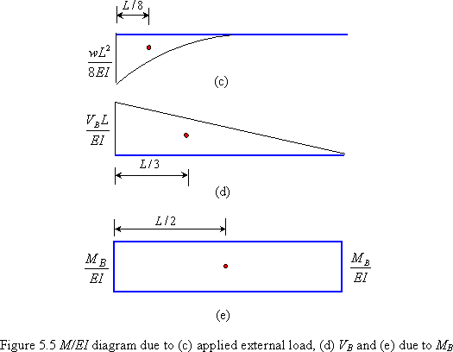

Since the change of slope between points A and B is zero (due to fixed supports at A
and B ), therefore, according to the first moment area theorem,

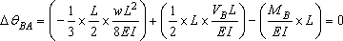

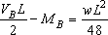
or (i)

Solving equations (i) and (ii)
or (ii)

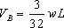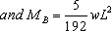

The bending moment diagram of the beam is shown in Figure 5.5(f)

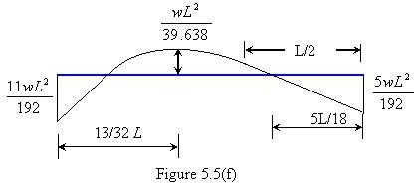

(b) Conjugate Beam Method

The corresponding conjugate beam (i.e. free-free beam) and loading on it are shown in Figure 5.5(g).

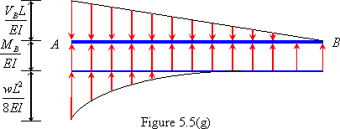

Considering vertical equilibrium of all forces acting on Conjugate beam

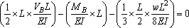

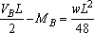
or (iii)

Taking moment about A

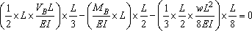

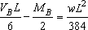
or (iv)

Solving eqs. (iii) and (iv)

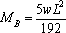

Example 5.5 The end B of a uniform fixed beam sinks by an amount D . Determine the end reactions using moment area method.

Solution: The degree of indeterminacy is 2. Let end reactions due to settlement at B be and as
shown in Figure 5.6(b). The M/EI diagram of the beam is shown in Figure 5.6(c).

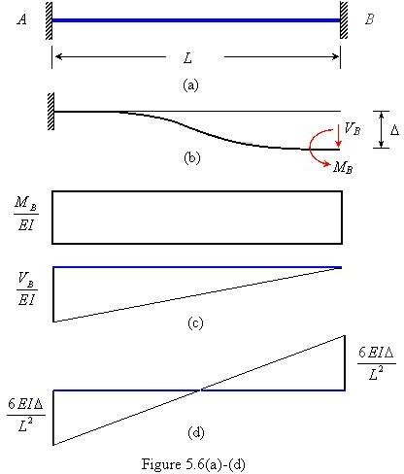

Applying first moment area theorem between A and B

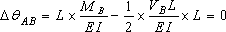

or (i)

Applying second moment area theorem between point A and B

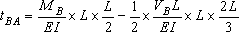

or
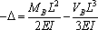
Solving eqs. (i) and (ii)

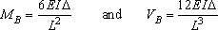

By equilibrium conditions, the reactions at support A are

and

Example 5.6 Determine the support reactions of the continuous beam as shown in Figure 5.7(a).

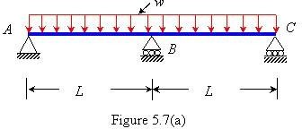

Solution: The static indeterminacy of the beam is = 3-2 =1. Let the vertical reaction at B be the unknown R
as shown in Figure 5.7(b). The M/EI diagrams of the beam are shown in Figure 5.7(c).

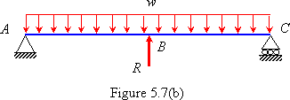
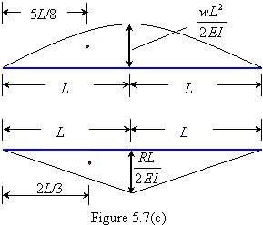

Because of symmetry of two spans the slope at B , As a result

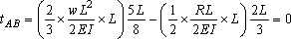

or or

The vertical reaction at A and C are

The bending moment diagram of the beam is shown in Figure 5.7(d).

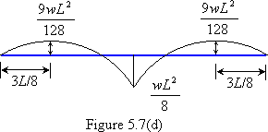

Recap
In this course you have learnt the following

Introduction to statically indeterminate structure.

Analysis of statically indeterminates beam using moment area and conjugate beam method.

To demonstrate the application of moment area and conjugate beam method through illustrative examples.

UNIT - V

Three Moment Equation

In this course you will learn the following
Objectives

Derivation of three moment equation for analysis of continous beams.

Demonstration of three moment equation using numerical examples.

Three Moment Equation

The continuous beams are very common in the structural design and it is necessary to develop simplified force method known as three moment equation for their analysis. This equation is a relationship that exists between the moments at three points in continuous beam. The points are considered as three supports of the indeterminate beams. Consider three points on the beam marked as 1, 2 and 3 as shown in Figure 5.25(a). Let the bending moment at these points is , and and the corresponding vertical displacement of these points are
, and , respectively. Let and be the distance between points 1 – 2 and 2 – 3, respectively.

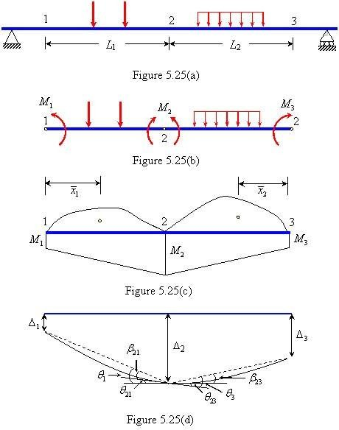

The continuity of deflected shape of the beam at point 2 gives

From the Figure 5.25(d)

(5.4)

and (5.5)

where

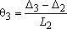
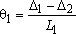
and (5.6)

Using the bending moment diagrams shown in Figure 5.25(c) and the second moment area theorem,

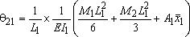

(5.7)

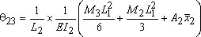
(5.8)

where and are the areas of the bending moment diagram of span 1-2 and 2-3, respectively considering the applied loading acting as simply supported beams.

Substituting from Eqs. (5.7) and Eqs. (5.8) in Eqs. (5.4) and Eqs. (5.5).

The above is known as three moment equation .

Sign Conventions
(5.9)

The and are positive for sagging moment and negative for hogging moment. Similarly, areas and are positive if it is sagging moment and negative for hogging moment. The displacements and are positive if measured downward from the reference
axis.

Example Analyze the continuous beam shown in Figure 5.26(a) by the three moment equation. Draw the shear force and bending moment diagram.

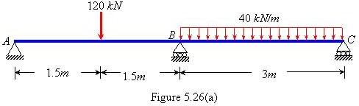

Solution: The simply supported bending moment diagram on AB and AC are shown in Fig 5.26 (b). Since supports A and C are simply supported

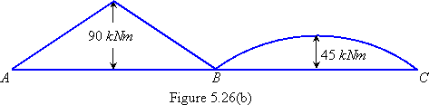

Applying the three moment equation to span AB and BC ( = = = 0)

or =-56.25 kN.m

The reactions at support A , B and C are given as

= 41.25 kN

= 41.25 kN

= 120 + 40 3 – 41.25 – 41.25 = 157.5 kN

The bending moment and shear force diagram are shown in Figures 5.26(c) and (d), respectively.

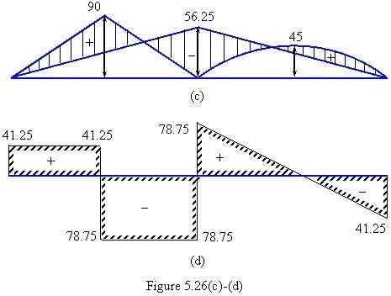

Example 5.23 Analyze the continuous beam shown in Figure 5.27(a) by the three moment equation. Draw the shear force and bending moment diagram.

Solution: The effect of a fixed support is reproduced by adding an imaginary span as shown in Figure 5.27 (b). The moment of inertia, of the imaginary span is infinity so that it
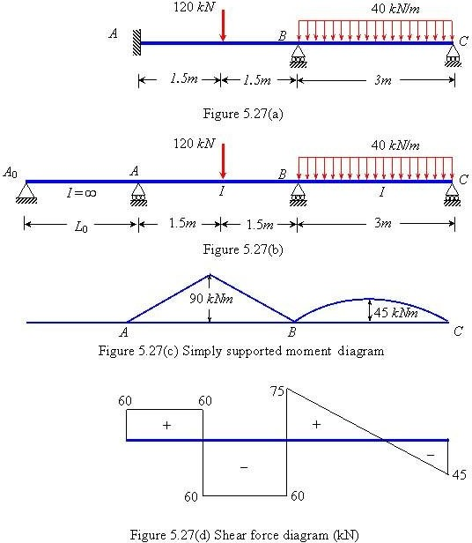
will never deform and the compatibility condition at the end A , that slope should be is zero, is satisfied.

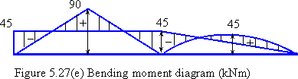

Applying three moment equation to the span and AB :

or

Span AB and BC :
+ = – 135 (i)

or + = – 225 (ii)

Solving Eqs. (i) and (ii), = – 45 kNm and = – 45 kNm

The shear force and bending moment diagram are shown in Figures 5.27(d) and (e), respectively.

Example 5.24 Analyze the continuous beam shown in Figure 5.28(a) by the three moment equation. Draw the shear force and bending moment diagram.

Solution: The simply supported moment diagram on AB , BC and CD are shown in Figure 5.28(b). Since the support A is simply supported, The moment at D is

.

Applying three moment equation to the span AB and BC :

or (i)

Span BC and CD : ( )

or (ii)

Solving Eqs. (i) and (ii) will give and .

The bending moment and shear force diagram are shown in Figures 5.28(d) and (c), respectively.

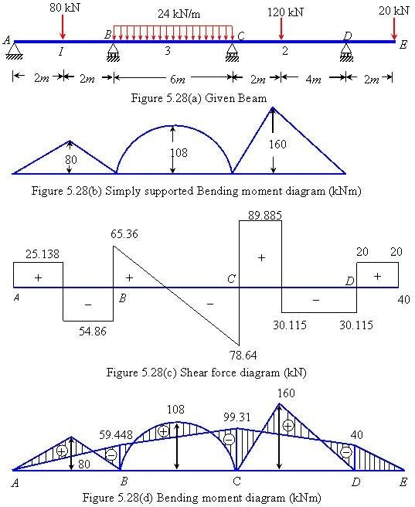

Example 5.25 Analyze the continuous beam show in Fig. 5.29(a) by the three moment equation method if support B sinks by an amount of 10 mm. Draw the shear force and bending moment diagram. Take flexural rigidity .

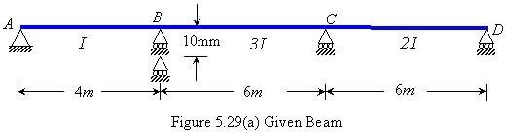

Solution: Since support A and D are simply supported.

Applying the three moment equation for span AB and BC : ( )

or (i)

Span BC and CD :

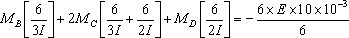

or |  |  |  |  | (ii)
Solving | Eqs. | (i) | and | (ii), | and

. The bending moment diagram is shown in Figure 5.29(b).

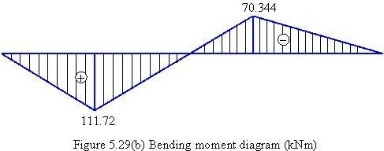

Example 5.22 Analyze the continuous beam shown in Figure 5.26(a) by the three moment equation. Draw the shear force and bending moment diagram.

Solution: The simply supported bending moment diagram on AB and AC are shown in Fig 5.26 (b). Since supports A and C are simply supported

Applying the three moment equation to span AB and BC ( = = = 0)

or =-56.25 kN.m

The reactions at support A , B and C are given as

= 41.25 kN
= 41.25 kN

= 120 + 40 3 – 41.25 – 41.25 = 157.5 kN

The bending moment and shear force diagram are shown in Figures 5.26(c) and (d), respectively.

Example 5.23 Analyze the continuous beam shown in Figure 5.27(a) by the three moment equation. Draw the shear force and bending moment diagram.

Solution: The effect of a fixed support is reproduced by adding an imaginary span as shown in Figure 5.27 (b). The moment of inertia, of the imaginary span is infinity so that it
will never deform and the compatibility condition at the end A , that slope should be is zero, is satisfied.

Applying three moment equation to the span and AB :

or

Span AB and BC :
+ = – 135 (i)

or + = – 225 (ii)

Solving Eqs. (i) and (ii), = – 45 kNm and = – 45 kNm

The shear force and bending moment diagram are shown in Figures 5.27(d) and (e), respectively.

Example 5.24 Analyze the continuous beam shown in Figure 5.28(a) by the three moment equation. Draw the shear force and bending moment diagram.

Solution: The simply supported moment diagram on AB , BC and CD are shown in Figure 5.28(b). Since the support A is simply supported, The moment at D is

.

Applying three moment equation to the span AB and BC :

or (i)

Span BC and CD : ( )

or (ii)

Solving Eqs. (i) and (ii) will give and .

The bending moment and shear force diagram are shown in Figures 5.28(d) and (c), respectively.

Example Analyze the continuous beam show in Fig. 5.29(a) by the three moment equation method if support B sinks by an amount of 10 mm. Draw the shear force and bending moment diagram. Take flexural rigidity .

Solution: Since support A and D are simply supported.

Applying the three moment equation for span AB and BC : ( )

or (i)

Span BC and CD :

or |  |  |  |  | (ii)
Solving | Eqs. | (i) | and | (ii), | and

. The bending moment diagram is shown in Figure 5.29(b).

Example 5.22 Analyze the continuous beam shown in Figure 5.26(a) by the three moment equation. Draw the shear force and bending moment diagram.

Solution: The simply supported bending moment diagram on AB and AC are shown in Fig 5.26 (b). Since supports A and C are simply supported

Applying the three moment equation to span AB and BC ( = = = 0)

or =-56.25 kN.m

The reactions at support A , B and C are given as

= 41.25 kN
= 41.25 kN

= 120 + 40 3 – 41.25 – 41.25 = 157.5 kN

The bending moment and shear force diagram are shown in Figures 5.26(c) and (d), respectively.

Example 5.23 Analyze the continuous beam shown in Figure 5.27(a) by the three moment equation. Draw the shear force and bending moment diagram.

Solution: The effect of a fixed support is reproduced by adding an imaginary span as shown in Figure 5.27 (b). The moment of inertia, of the imaginary span is infinity so that it
will never deform and the compatibility condition at the end A , that slope should be is zero, is satisfied.

Applying three moment equation to the span and AB :

or

Span AB and BC :
+ = – 135 (i)

or + = – 225 (ii)

Solving Eqs. (i) and (ii), = – 45 kNm and = – 45 kNm

The shear force and bending moment diagram are shown in Figures 5.27(d) and (e), respectively.

Example 5.24 Analyze the continuous beam shown in Figure 5.28(a) by the three moment equation. Draw the shear force and bending moment diagram.

Solution: The simply supported moment diagram on AB , BC and CD are shown in Figure 5.28(b). Since the support A is simply supported, The moment at D is

.

Applying three moment equation to the span AB and BC :

or (i)

Span BC and CD : ( )

or (ii)

Solving Eqs. (i) and (ii) will give and .

The bending moment and shear force diagram are shown in Figures 5.28(d) and (c), respectively.

Example 5.25 Analyze the continuous beam show in Fig. 5.29(a) by the three moment equation method if support B sinks by an amount of 10 mm. Draw the shear force and bending moment diagram. Take flexural rigidity .

Solution: Since support A and D are simply supported.

Applying the three moment equation for span AB and BC : ( )

or (i)

Span BC and CD :

or (ii)

Solving Eqs. (i) and (ii), and
. The bending moment diagram is shown in Figure 5.29(b).

Example Determine the support reactions of the propped cantilever beam as shown in Figure 5.2(a).

Solution: The static indeterminacy of the beam is = 3 – 2 = 1. Let reaction at B is R acting in the upward direction as shown in Figure 5.2(b). The condition available is that the .

(c) Moment area method

The bending moment diagrams divided by EI of the beam are shown due to P and
R in Figures 5.2(c) and (d), respectively.

Since in the actual beam the deflection of the point B is zero which implies that the deviation of point B from the tangent at A is zero. Thus,

or

Taking moment about A , the moment at A is given by

The vertical rection at A is

The bending moment diagram of the beam is shown in Figure 5.2(e).

(d) Conjugate beam method

The corresponding conjugate beam of the propped cantilever beam and loading acting on it are shown in Figure 5.2(f).

The unknown R can be obtained by taking moment about B i.e.

Recap
In this course you have learnt the following

Derivation of three moment equation for analysis of continous beams. Demonstration of three moment equation using numerical examples.

